12.81: The radius of the semicircle is 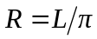
Divide the semicircle up into small segments of length 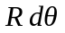

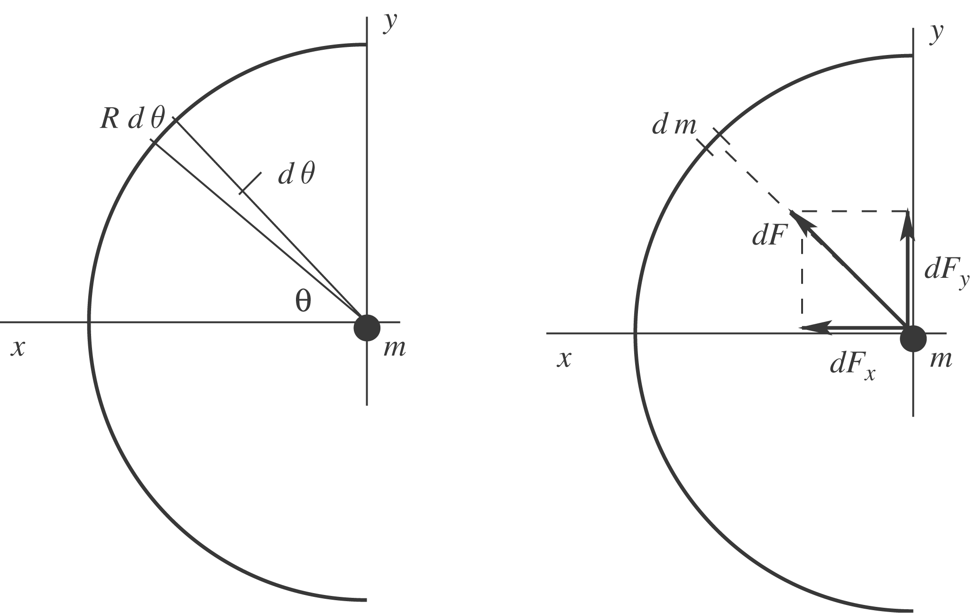

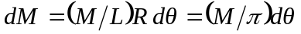
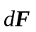 is the gravity force on 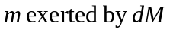
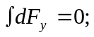 the y-components from the upper half of the semicircle cancel the y-components from the lower half.
The x-components are all in the +x-direction and all add.

